
CANDOER News

A quarterly Newsletter dedicated to Communicators AND Others Enjoying Retirement

April 2014 Spring Issue Volume 14 – Number 1

Inside this issue

Cat's Corner 2
By Bob Catlin

Strange Coincidence 2
By Jim Prosser

From the Halls of Montezuma to the Soviet Embassy 3
By John Lemandri

Appalachian Trail Hike 2002 3
March 14 – September 17
By Rey Grammo

Retirement life with Erick G. Morin, Retired 5

Welcome to the latest issue of the Newsletter dedicated to the CANDOERs (Communicators AND Others Enjoying Retirement). This newsletter will be published quarterly. New issues will be posted on the Web for your reading enjoyment on or about, January 15, April 15, July 15, and October 15.
The CANDOER web site and newsletter may be viewed at: www.candoer.org.

The success of this newsletter depends on you. I need story contributors.

Do you have an interesting article, a nostalgia item, or a real life story you would like to share with others? If you do, please send it to me at the following e-mail address:

candoercat@gmail.com

or to my snail-mail address:

Robert J. Catlin, Sr.
2670 Dakota Street
Bryans Road, MD 20616-3062
Tel: (301) 535-9263
Please, NO handwritten submissions.
This newsletter is available on the Web only, free, to any and all.
None of the material in this newsletter has a copyright, unless otherwise noted. If you wish to print the newsletter and make copies to distribute to others, please feel free to do so.
The CANDOER Newsletter will be available in three formats: as a Web Page; as an Adobe PDF file; and as a Microsoft Word document.
The PDF file and Microsoft Word document will allow you to download and print the newsletter exactly as if I had printed it and mailed it to you.

Q. What do bulletproof vests, fire escapes, windshield wipers, and laser printers have in common?
A. All were invented by women.
Cat's Corner

Well, here it is, spring, finally! Most of you probably experienced the same winter we did here in Southern Maryland, cold, cold and then, more cold. I spent so much time inside it started to feel like I was in prison.
In this issue, I have published the first three days of a 187 day walking trip Rey Grammo took in 2002. He walked from Georgia to Maine on the Appalachian Trail. His story is over 78 pages long. You can read the entire story on the CANDOER Web site by going to the Main Menu and clicking on the tab, "Serial Stories" and then clicking on "Appalachian Trail Hike 2002."
The one-liners between stories in this issue were received from my oldest brother, Ernie and are called, "Stuff you didn't know you didn't know!"
Men can read smaller print than women can; women can hear better.
Strange Coincidence
By James F. Prosser

Several years ago my Aunt Marie was a court reporter, in Green Bay, Wisconsin, by profession and did a fair amount of traveling to nearby locations, especially to take depositions. She and my Uncle Gordon had just purchased a new 1990 Buick sedan.
One day she had a job to do in Sturgeon Bay, 45 miles north of here. She drove up there, parked her car in the courthouse parking lot, spent about three hours on the job, and then returned home after lunch.
Uncle Gordon, returning home from work that afternoon, went to the car to get the gardening tools he previously had left in the trunk a couple days before. Opening the trunk, he did not find his gardening tools, but instead bundles of a salesman's brochures and order forms.
He went into the house, explained what he found and asked Marie for an explanation as to where his gardening tools were. Unable to figure what this was all about, they both went back outside to the car and then discovered that the license plate was not theirs! Checking the glove box for the vehicle registration/insurance items they found the car belonged to a person in Plymouth, Wisconsin, 85 miles south of Green Bay!
So they went back inside the house and telephoned the owner. A gentleman answered. Marie says, "Sir, I happen to have your car and believe you have mine." The guy in Plymouth exclaims, "Impossible. My car is in my driveway and I see it right now from where I am standing." Marie then tells him he better go out and check the license plates, which are xxx-xxxx, and inside the trunk he would find a bunch of gardening tools. The guy says, "Just a minute. I'll go and check." Coming back to the phone, incredulously he asks, "How did you get my car? How did I get your car?" Marie said she was in Sturgeon Bay that day working inside the courthouse. The guy said he also was in Sturgeon Bay, and parked in the courthouse parking lot while making sales calls in nearby establishments. Neither of them could comprehend how their ignition keys would work in another car.
Discussing the complexities of the situation; i.e., identical new cars, not noticing they parked adjacent to each other, same ignition keys, color and other amenities, etc., they agreed it would be best for both parties to take their spouses for supper at a particular restaurant in Manitowoc, Wisconsin, approximately half-way between Green Bay and Plymouth to make the exchange while having a good laugh.
The two cars, while identical in all major respects, were purchased from dealers considerably distant from each other. The Green Bay Buick dealer explained to my Aunt that General Motors only used a few dozen variations of ignition keys. Incredibly, these two vehicles had the same ignition keys installed, even though they were produced a few weeks apart!
How's that for a strange coincidence?

The State with the highest percentage of people who walk to work:
Alaska.
From the Halls of Montezuma to the Soviet Embassy
By John Lemandri

While in Guinea Bissau, West Africa, our small embassy staff hosted the first U.S. Navy ship to travel up the estuary and visit that country. As a former "Leatherneck" (nickname from a bygone era when a strip of leather protect one's neck from saber cuts), I was put in charge of athletics for a platoon of Marines who I led on a five mile jog through the city as we sang the Marine Corps Hymn.
Never one to miss an opportunity, I diverted the platoon to the Soviet Embassy where we circled, round and round, while "From the Halls of Montezuma To the shores of Tripoli," echoed throughout the streets.
A late day soccer game between the Marines and the host country team was attended by nearly the entire town, national assembly, and Guinea Bissau's president. The score was tied midway through the match when the Marine's top scorer ripped his shorts right down the middle. The Marines, never at a loss to improvise, huddled on the field. Without missing a beat, the high scorer and another Marine, their near naked butts facing the crowd, changed shorts as thousands of Guinea Bissauans went wild, cheering, laughing, and applauding for nearly a minute. In an instant what could have been an embarrassing moment did more good for bi-lateral relations than a million dollar aid package.

The percentage of Africa that is wilderness: 28%
(now get this...)
the percentage of
North America that is wilderness: 38%

Appalachian Trail Hike 2002
March 14 – September 17
By Rey Grammo

Why would anyone want to walk over 2,000 miles from one end of the country to the other? It isn't an easy question to answer, and of course to most people this would sound like a crazy idea. For many years this was a fantasy of mine, which I am happy to say, was realized with the help of many, many people.
I believe my first thought of doing this hike came about during the time I was leading the boy scouts from Sterling, VA on various hikes. It so happened that they were taking a hike on the Appalachian Trail and I was unable to go with them for the full hike due to a previous commitment. It was with great difficulty that I had to turn back as they entered the trail and see them head off into the woods. I was determined that someday I would be hiking this trail. The other incident that convinced me that some day I would hike the trail was when we were visiting my wife's sister, Sue and her husband Chicky in New Hampshire and he led a hike up Mt. Manodnock.
From that moment on I was definitely hooked. I read everything I could about the trail as well as joining the Appalachian Trail Conference. I obtained a large map of the Appalachian Trail and framed and hung it in our family room where it hung for many years.
Although I had retired in 1994 from the State Department, I continued to work part time until early 2002. During the last year of my working, I was preparing myself for the hike. I walked a lot, worked out in the gym for the last three months before my departure, and began collecting the supplies that I needed. Considerable planning was required to decide what food to take, how much and where my drop points would be. I acquired a workbook that gave many good hints as to what was and was not needed as well as how I should plan my food drops at the various locations along the way. During this time, I traveled to New Jersey where I picked up over $300.00 worth of equipment at Campmore. Some of the items purchased were clothing such as shorts, shirts, underwear, and socks. I purchased a headlamp, food bag, stuff bags, a one-person tent, walking sticks, and other items I felt I needed. I really had no idea what I really needed to purchase having never hiked or camped for this length of time. I could only rely on what I read in the manuals and booklets that I had read and what other hikers were telling me. I read many hiker journals and put all the information together to determine what I thought I would need. Did I select the right equipment? Only time and many miles will tell.
As my time is drawing closer, I am becoming more and more apprehensive and wondered if I really was prepared for such a journey. Of course by this time I had told so many people about what I planned to do that there was no way I could back out. I at least had to start the journey and if I had to, I could always quit the adventure and return home. I didn't like the word quit, but this would be a final option if necessary.
The time finally arrived for Amy and Mike to take me to Georgia where I would begin my journey.
It was a good trip and after checking into the motel and having a good meal we did a dry run to Amicalola Falls State Park. We thought at the time, that there would be no problem finding the trailhead so we went back to the motel for an early night in preparation for a very long day the next day. And so, my venture begins:
3/14 - Thursday - Day 1 – 2.5 miles – (Mile Marker 2.5) We woke up to a beautiful day and I was soon ready to head off to the Springer Mountain trailhead. However, when we tried locating the road leading to the parking lot which was supposedly 0.9 miles from the summit of Springer Mountain, we couldn't locate it. Consequently, after several attempts, we decided I should get out where the trail crossed over the road and continue from there. I was just a bit embarrassed immediately upon departing on the trail. It seems that I was starting out in the wrong direction. Fortunately, I immediately met some hikers who were on their way up the mountain and once getting turned around, I was then on my way for sure. I guess this unnerved Mike and Amy just a little to think that I hadn't even begun my hike and I was already heading in the wrong direction. After a few of their remarks and their final instruction to "now walk home, Dad", I was on my way. I hiked about 3.5 miles to the summit where I met my first two through hikers. Kali and Pippi were from Charlottesville and I knew I would most likely cross paths with them several times over the next several weeks. Little did I realize at this time that almost everyone I met would introduce themselves as a through hiker because they all truly believed they would hike the entire trail as I intended doing.
There was a small monument indicating the top of Springer Mountain. After signing the logbook at the summit, (3,782 feet) I officially began my hike of the Appalachian Trail. Since it was rather late, I only hiked as far as Stover Creek Shelter (alt. 2,870). There was a good water supply at this site. Excitement filled the air with everyone just beginning the hike. Since the shelter was full, I set up my tent for the first time and was tucked in early with visions of what the following day would be like. Every day would be a new experience and I was anxious for it to begin.
3/15 – Friday - Day 2 – 5.1 miles – (Mile Marker 7.6) I was up at 6:30 and off at 7:15. It will take a little while to get myself organized and know where everything is in my pack, when to fill my water bottle, (best to do this at night before bed) as well as what and when to eat meals. It will also take time to get into a routine when arriving at the nights destination such as locating the water supply and filtering the water for dinner as well as filling the morning water bottles, when to cook the meal, deciding whether to set up the tent or sleep in the shelter. I took a side trip to Long Creek Falls (2,740). Although this would have been a good place to take a dip with several cascades and a pool at the bottom, it was a bit too cold for that. Today's hike included a couple of pretty tough hills. I reached Hawk Mountain Shelter (3,260) early and considered continuing on, but it was another 8.5 miles to the next shelter. Since rain was in the forecast, I decided I didn't want to get soaked and didn't think I would make it to the next shelter before dark so I decided to stop for the day. Since I got in early, I had lots of time to kill and rest. We ended up having a total of 17 people and one dog at the shelter tonight. Since this is the beginning of the hike, I fully expect that we will have lots of people at the shelters most nights until we get further on into the hike. It is interesting to note that along this stretch of the trail the Army Rangers from nearby Camp Frank D. Merrill practice their maneuvers. They try and track the hikers without the hikers knowing they are there. Either I am not very observant, or they are really good at what they are doing. I didn't see or hear a one if in fact they were actually out there.
3/16 – Saturday - Day 3 – 8.5 miles – (Mile Marker 16.1) I had a rough night in the shelter with all those people, lots of snoring and talking. Today I got an early start and headed for Gooch Gap Shelter (2,930) at mile marker 16.1 where I planned to spend the night. I hiked up Justus Mountain at 3,224 feet prior to getting to my final destination of the day. In between there were lots of ups and downs. I found the hike tough today. I guess I am not in the shape I thought I was, as all the mountains/hills seem tough at this point. I had a steep 0.2 mile climb to get to the shelter. I will hit the sack early tonight. Although the hike was tough today, the scenery was great. This is my third day on the trail and I have only done 16.1 miles. However, I am doing the short mileage as suggested until I get my hiking legs and feel I am in shape to do longer miles. This serves a couple of purposes, one that you don't blow yourself out and come up with an injury and secondly, so you don't get overtired and discouraged with the hike before you have an opportunity to get in shape.

The cost of raising a medium-size dog to the age of eleven: $ 16,400

Retirement life with Erick G. Morin, Retired FE-OC

My wife and I retired last year and moved down to a lovely, quiet place on Lake Hickory in Conover, North Carolina. Once we got settled, I started looking for a volunteer job so I could get out, meet people and keep busy helping people in the community. I found the perfect volunteer job for me. I am working at an Equestrian Therapy Center in Claremont, North Carolina. The name of the center is Rising Hope Farms (RHF). RHF is a faith-based 501(c)(3) charitable organization and equestrian facility that offers therapeutic riding. It provides activities to positively influence social, cognitive, physical and emotional health in children and adults with disabilities. I have found this to be so rewarding both physically and mentally for me as well.
My primary volunteer job at the farm is to be a side-walker. Some of the riders are unable to stay in the saddle of their own volition, so I walk alongside the horse and make sure they can have a safe riding session. When the horse trots, I trot alongside the horse. In a typical week, I volunteer for four sessions a day, twice a week, so I am getting some well needed exercise. Sometimes I take on the additional responsibilities of Horse Handler. I lead the horse around the arena with the riders and I tack and groom the horse before and after the riding sessions. I prefer the side-walking job, as I love the one on one interaction with the riders. Horse Handlers must focus only on the horse to make sure the rider has a safe and comfortable riding session. In addition, I also help out with farm chores such as cleaning stables, fixing broke fences and numerous other tasks that need to be done to maintain a farm. So just like my career with State, I am still fixing broke things. I am presently in the process of becoming a certified, Professional Association of Therapeutic Horsemanship (PATH) instructor, so I can lead the sessions if something happens to one of the three current instructors at the farm.
RHF offers programs for many different groups of people. RHF offers a bereavement program called “Hoofs for Hospice” that uses horses to help children and young adults cope with loss. Its “Horses for Heroes” program is staffed by military personnel and offers certified instructor to help veterans through the healing process. I am in the process of assuming the responsibilities as the Veterans Coordinator to take over the “Horses for Heroes” program. At present RHF has one Veteran that rides with the program. He is a Vietnam Vet who was wounded and lost his vision. Over the last two years I have worked with the Veteran and he can now ride alone and go on trail rides with me.

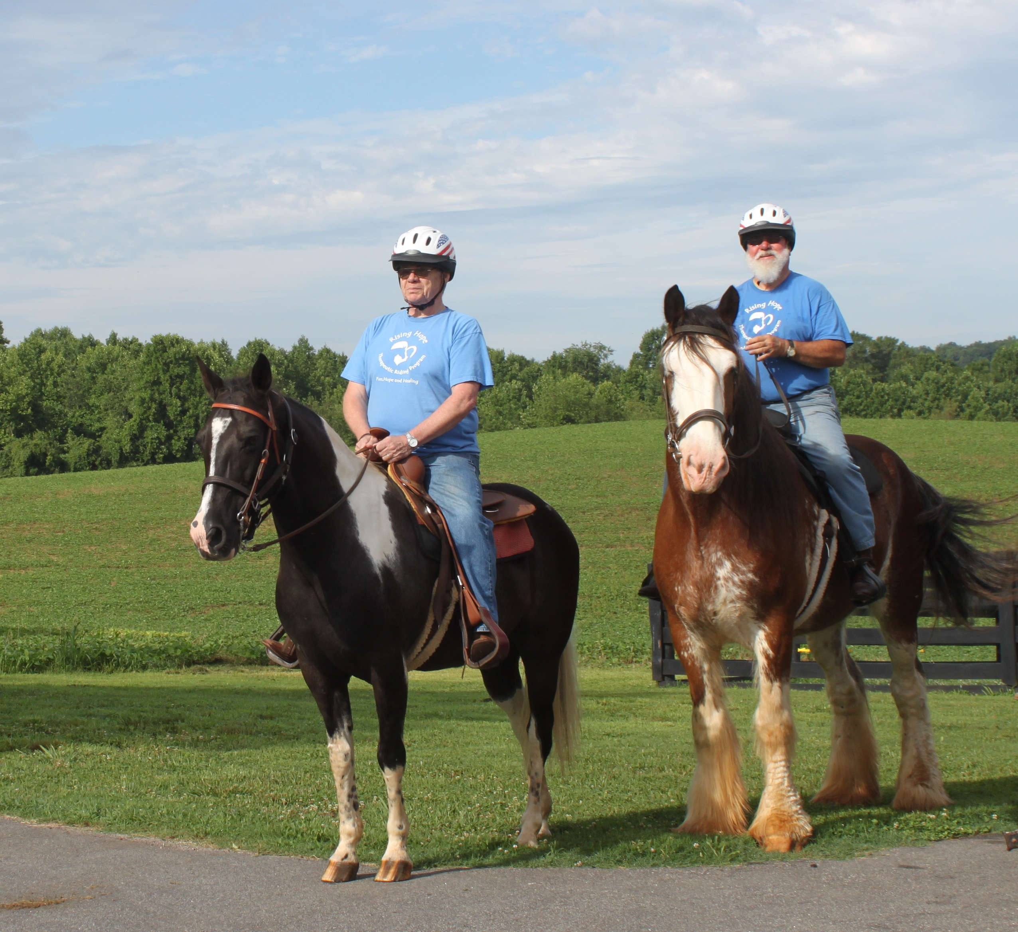
RHF needs help to build an indoor arena to allow our riders to obtain their therapy all year long. RHF has obtained the property for the planned arena; however, the project requires more funds than the farm has available. The project is “estimated at $500K” to build the equestrian center that can provide year round services to the Veterans and therapy riders. If you are planning to donate to a worthy charity, please think of Rising Hope Farms.
Donations can be made on line at:
http://www.risinghopefarms.com/donate.shtml
or mail:
Make checks payable to:
Rising Hope Farms
3775 Bethany Church Road
Claremont, NC 28610

Each king in a deck of playing cards represents a great king from history:
Spades --- King David
Hearts --- Charlemagne
Clubs --- Alexander, the Great
Diamonds --- Julius Caesar

See you next quarter!

